

**Borough 18 Motor Club/ Weald Motor Club**

12 Car Rally

**19th October 2018**

50 miles of classic North Downs roads on maps 178 & 189

Start: ***Bangers*** ***Cafe*** Detling Hill (A249) 178/ 812590

7pm for 7.30pm Start (See Regs.) Entry: £ 15

**Rally insurance available on the night by** JELF **Insurance Services (£16)**

Navigation will be straightforward but will require accurate plotting.

Thanks to the generosity of Utting Estates Limited, a degree of financial support will be available during this current series in order to stimulate interest for beginner crews. The introduction of 12-Car Rallies many years ago was intended to encourage newcomers into rallying and today this is still very much the principle aim. In this series beginners will be very welcome and a subsidy of £15.00 will be available on each round as a contribution towards their expenses.

**Entries to**: Roger Keene See entry form below [roger.keene@ntlworld.com](mailto:roger.keene@ntlworld.com)

***\**** *If you are unable to enter, then please come along and help with marshalling.*

Marshals please contact: Dave Clark 01474 833496 (home)

07967 627833 e-mail: [daveclark1949@btinternet.com](mailto:daveclark1949@btinternet.com)

[*http://borough18motorclub.weebly.com/*](http://borough18motorclub.weebly.com/)

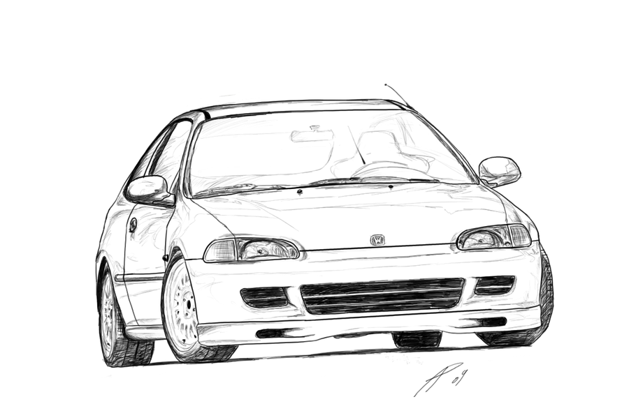

**BOROUGH 18 MC 12 CAR RALLY 19th October 2018**

**ENTRY FORM *PLEASE PRINT* Entry fee: £ 15**

**Post to: 39 New Road London SE2 0QH**

or e-mail: roger.keene@ntlworld.com

Please make payment (£15) direct to **Nationwide**

**sort code 07-04-36 account no 15212542**

giving : **OCT 12 CAR** and then the **DRIVERS** surname as reference, otherwise we will not be able to process your entry.

**Driver’s Name** ……………………………………………………………………..

Address ……………………………………………………………………………....

……………………………………………………Postcode…………………………

Tel No………………………………. e-mail …………………………………

**Navigator’s Name** ………………………………………………………………….

Address………………………………………………………………………………

……………………………………………………Postcode…………………………

Tel No. ………………………………. e-mail …………………………………

**Car** Make/Model………………………………..…. c.c. ……………

Registration No. ………………………………..… Colour ……………………….

Class entered: Expert/ Semi/ Novice/ Beginner

**Insurance**

I will be using the JELF insurance facility …yes/ no (To be paid on the night)

or Private Insurance – Company Name……………….....………………

Policy No. ……………………

Please give these details of who can be contacted in the event of an accident.

Name ……………………………… Tel No. ……………………..

Please sign the following **Declaration of Indemnity:**

(1) I declare that I have been given the opportunity to read the General Regulations of the Motor Sports Association and the Supplementary Regulations for this event and agree to be bound by them. I declare that I am physically and mentally fit to take part in the event and I am competent to do so. I acknowledge that I understand the nature and type of the competition and the potential risk inherent with motor sport and agree to accept that risk. Further I understand that all persons having any connection with the promotion and/or organisation and/or conduct of the event are insured against loss or injury caused through their negligence.

(2) I declare that the use of the vehicle hereby entered will be covered by insurance as required by the law which is valid for such part of this event as shall take place on roads as defined by the law.

Drivers Signature ……………………………………….. Age if under 18 …...…………

Motor Club ………………………………...Card No. ……………………………………

Navigator’s Signature ……………………………………… Age if under 18 ……………

Motor Club…………………………………Card No. …………………………………..

Date …………………

**THIS ENTRY IS MADE WITH MY CONSENT (if aged under 18):**

**Parent/Guardian of DRIVER** Signature ………………………………………………..

Full Name of Parent/Guardian …………………………………………………………….

Relationship …………………………………………. Tel. No: ………………………….

Address …………………………………………………………………………………….

**Parent/Guardian of NAVIGATOR** Signature …………………………………………

Full Name of Parent/Guardian …………………………………………………………….

Relationship …………………………………………. Tel. No: ………………………….

Address …………………………………………………………………………………….